Task 7 :- 1) update 2)Alter 3)Delete on view table

1. UPDATE :-

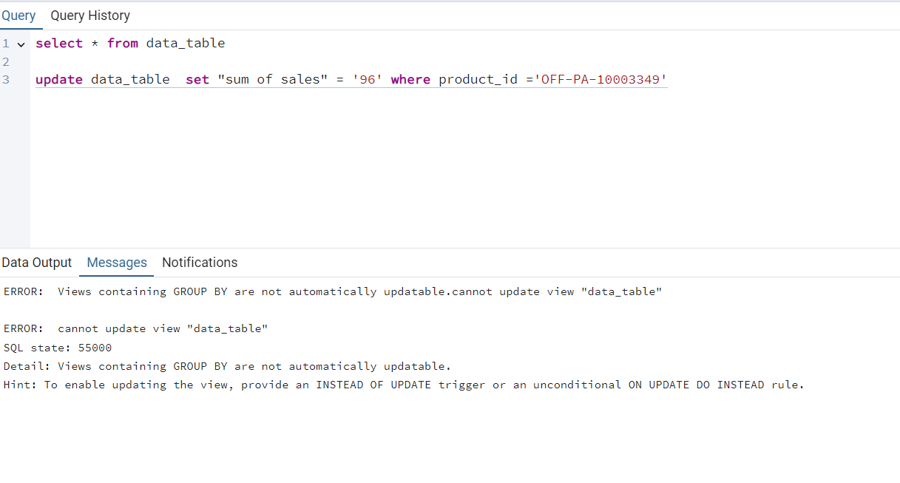

* The view table is not update when we run update querry on view table
* And when we update any value in original table the view table is not affect by that the view table remain constant

1. ALTER :-

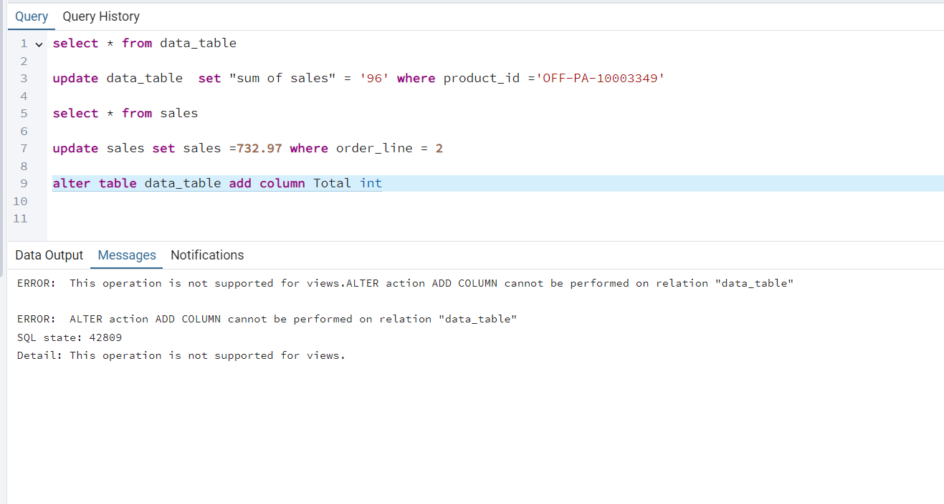

--- adding column

* The alter querry for adding columns cannot run in view table
* As well as we can’t drop the column in view

----- rename column

* The alter rename querry run on view

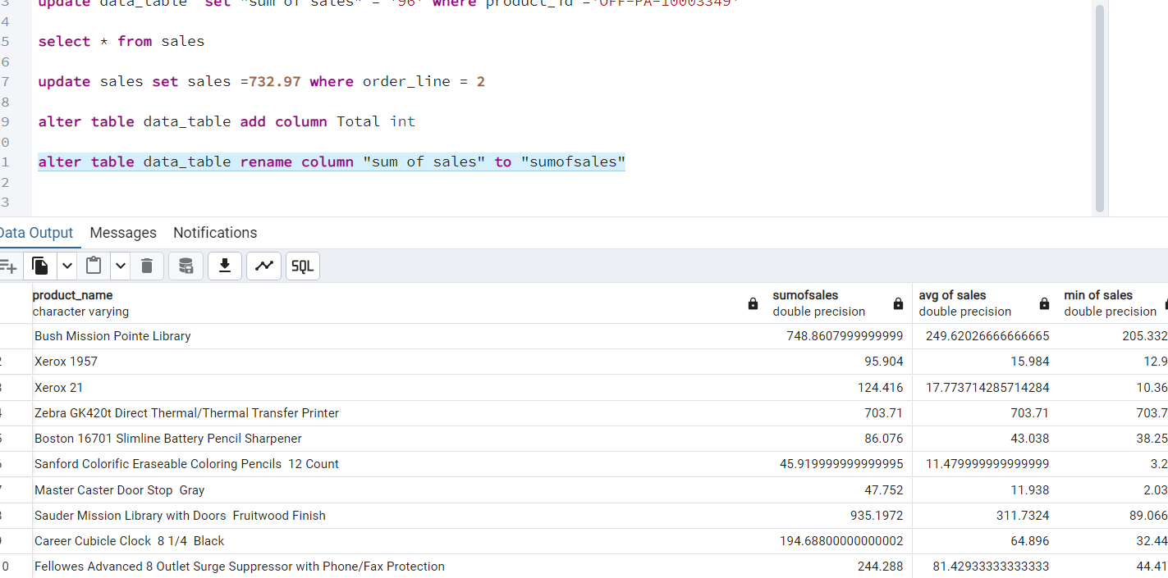

3)DELETE:-

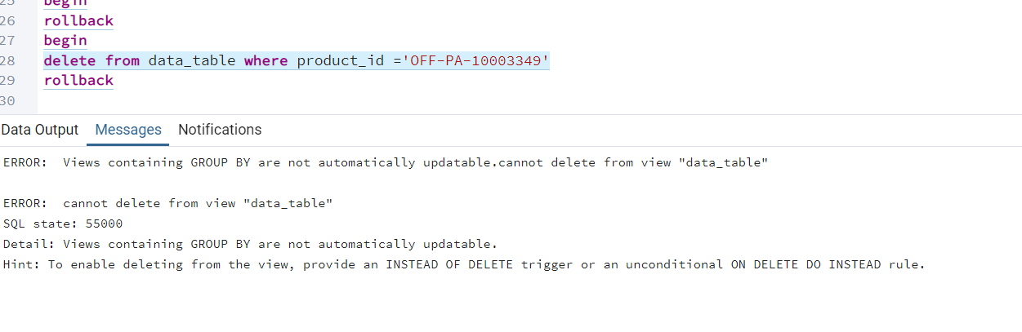

* The delete row querry cannot run on view table

